Django Bootcamp

Day - 1

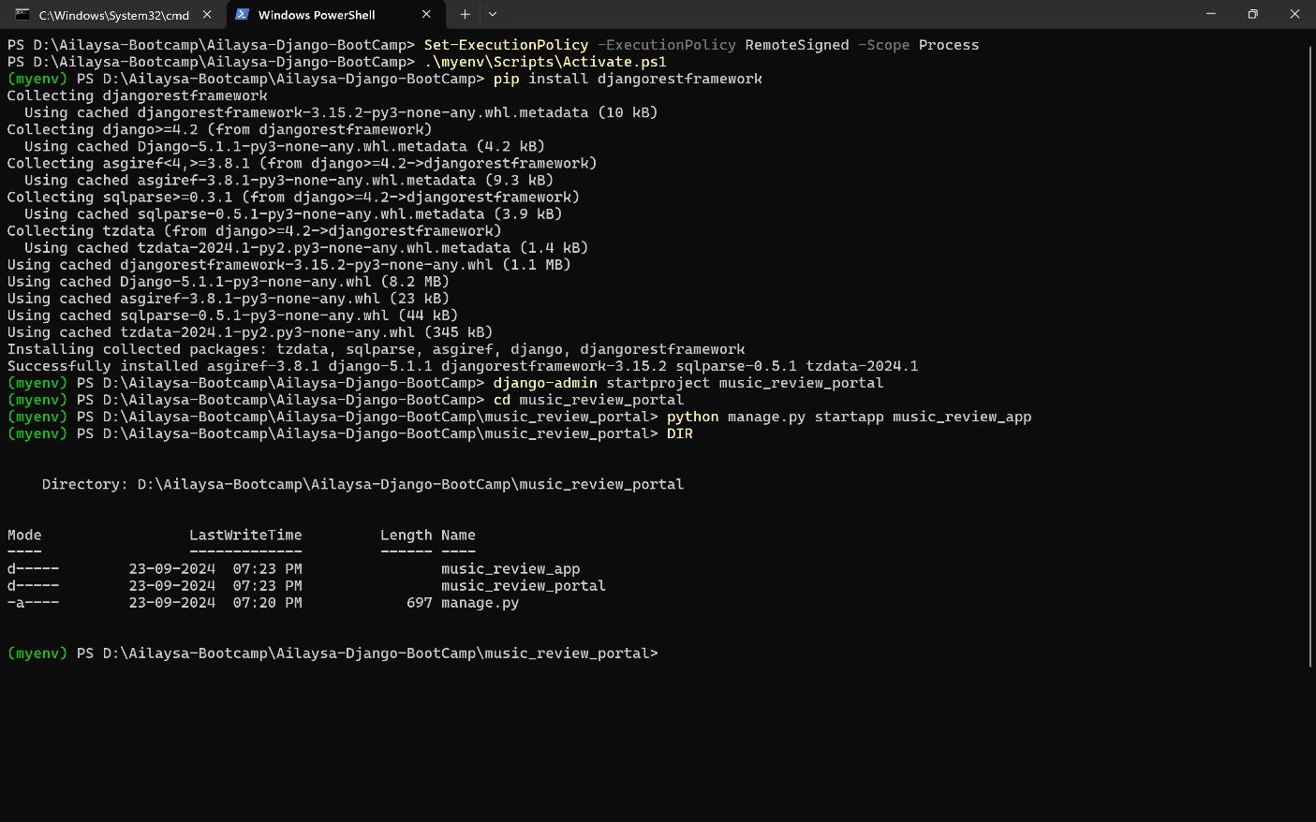Open Windows Powershell in the corresponding folder and type the below commands:

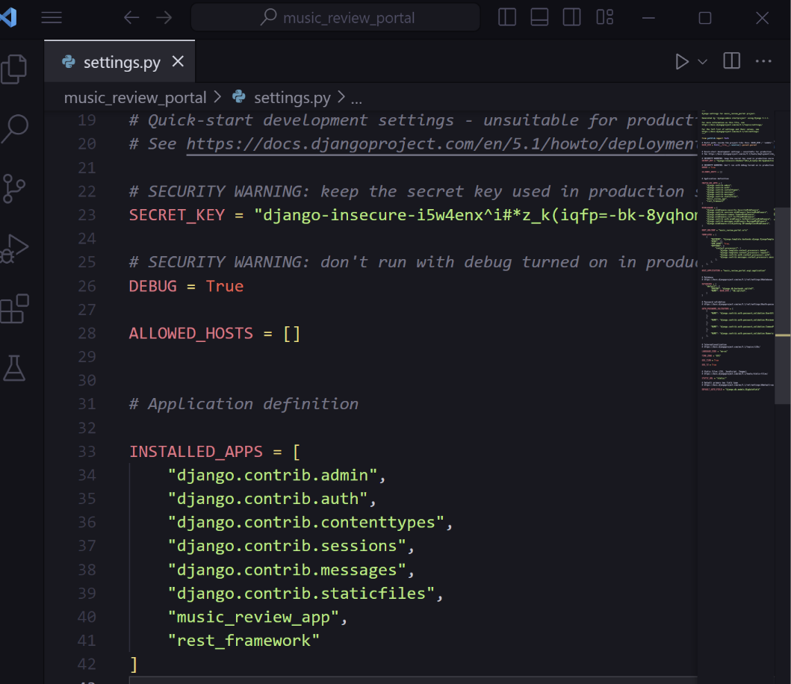In the project folder, go to settings and add the newly installed apps, i.e app u created and the rest_framework installed

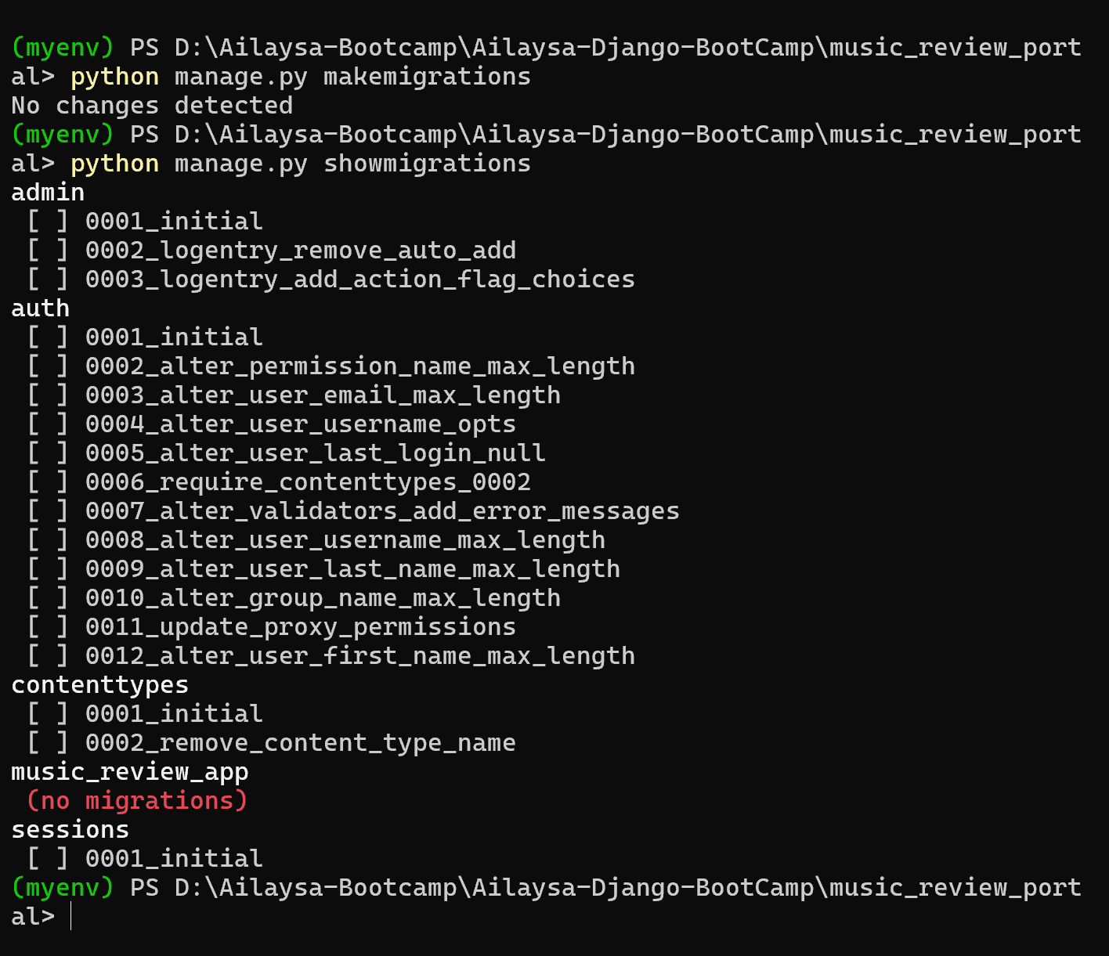To init migration run the following commands

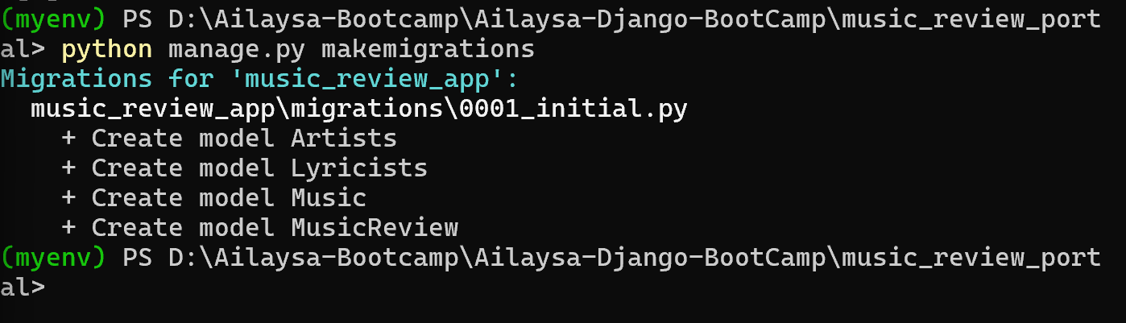After creating the classes in models.py file, to create sql tables , type the below commands, a db.sqlite3 file will be created

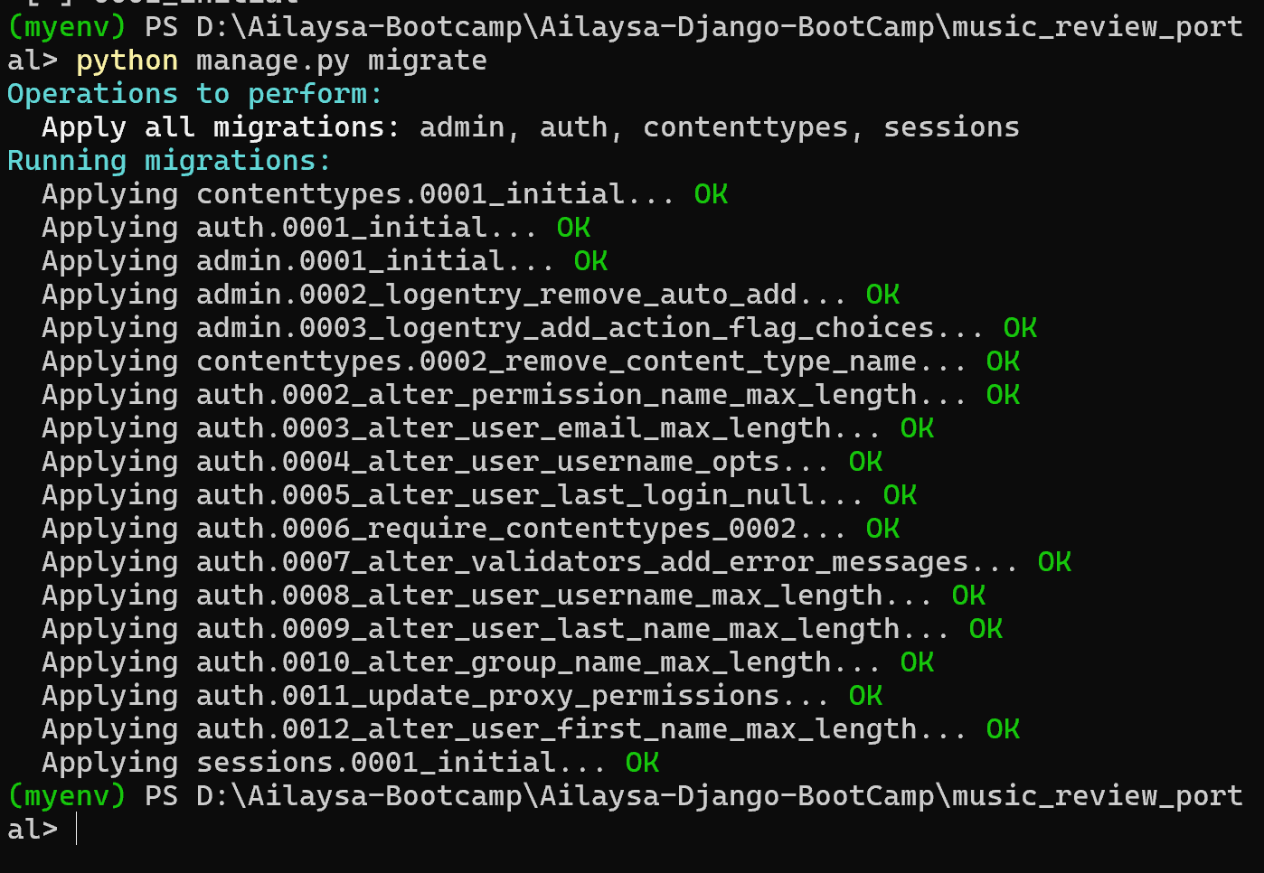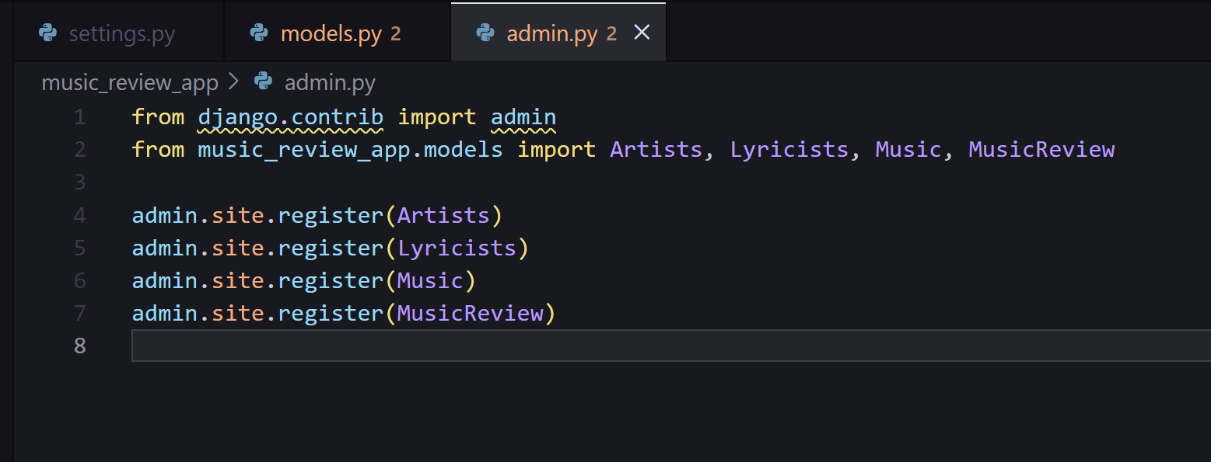After that import the classes in the admin.py file to create a inbuilt UI

Create a superuser for login, To run the app, type the below command and go to

<https://127.0.0.1:8000/admin>

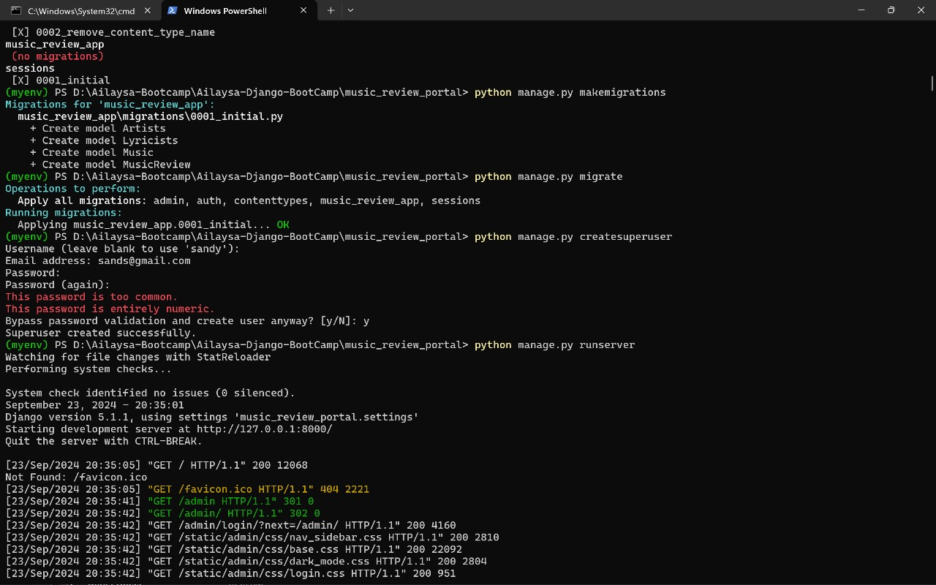

**Day – 2 -> INTRODUCTION TO ORM**

Viewing data in the tables using commands in shell

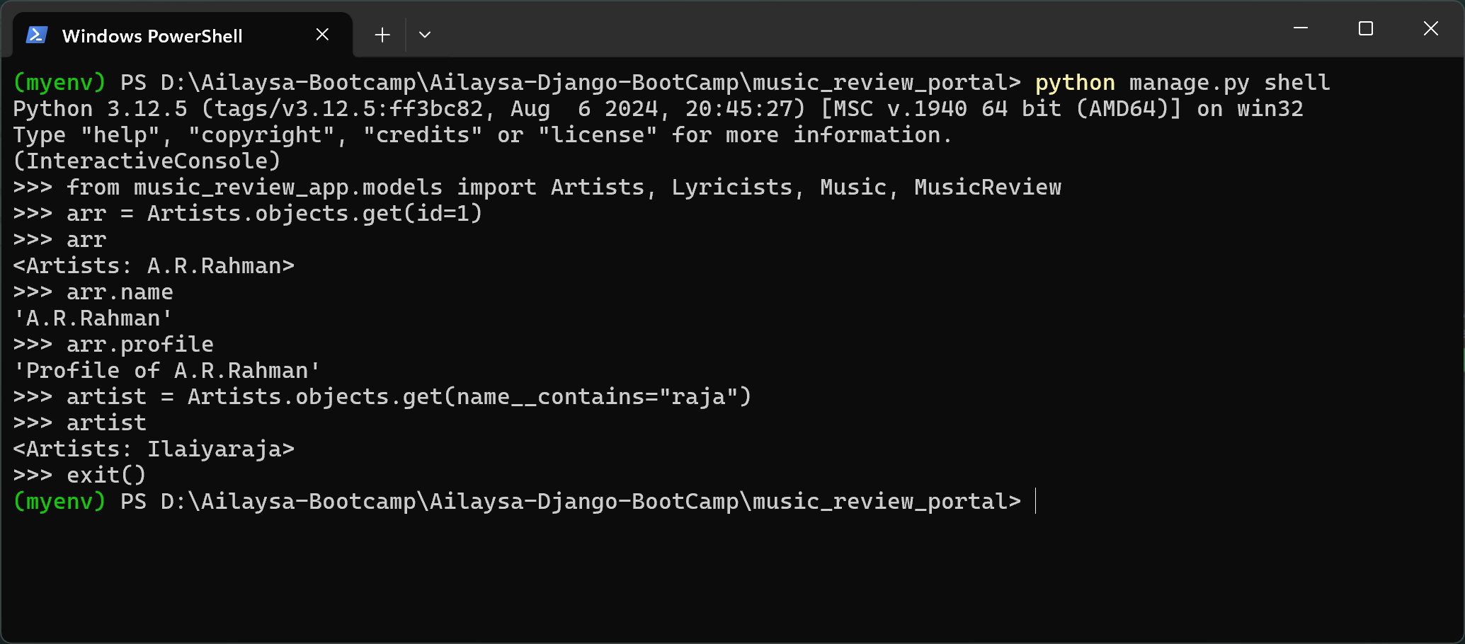

Install IPython

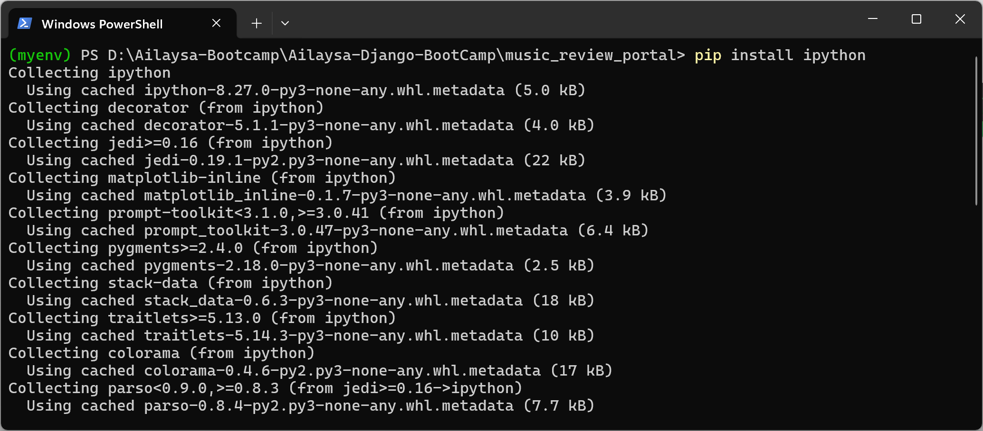

Commands

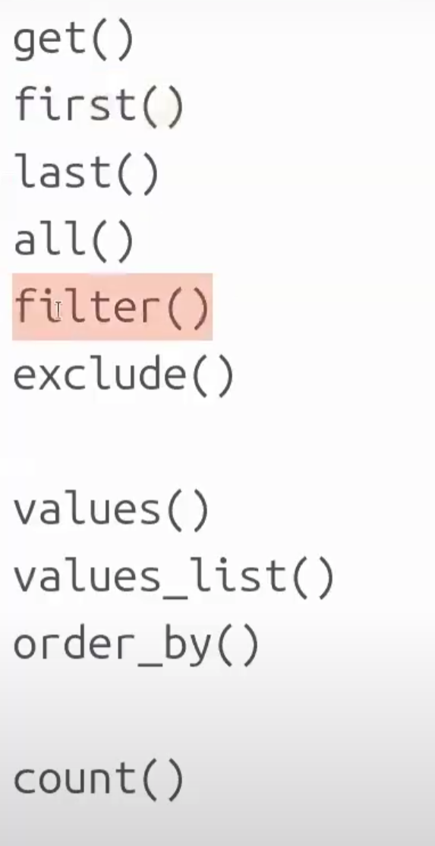

get() method is used to get one data at a time

filter() method helps to get more data

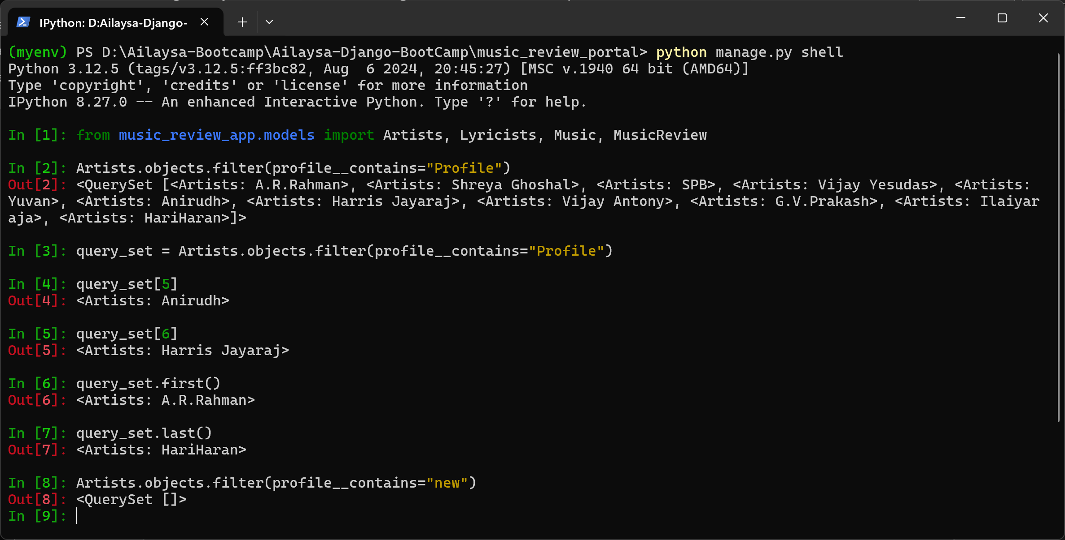

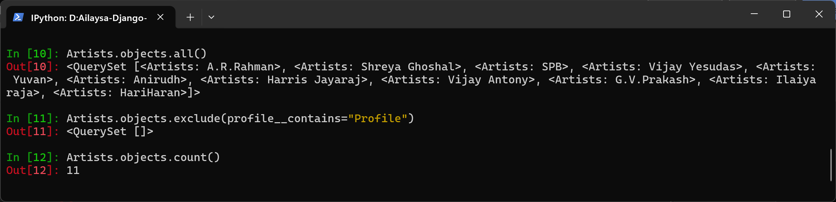

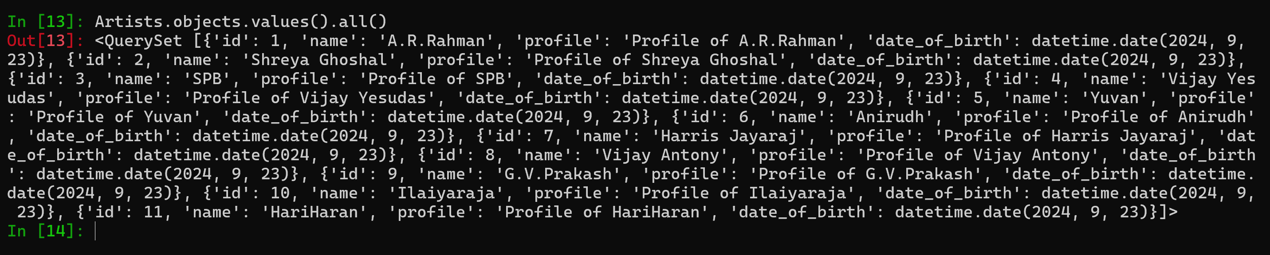

Click tab to see the all methods

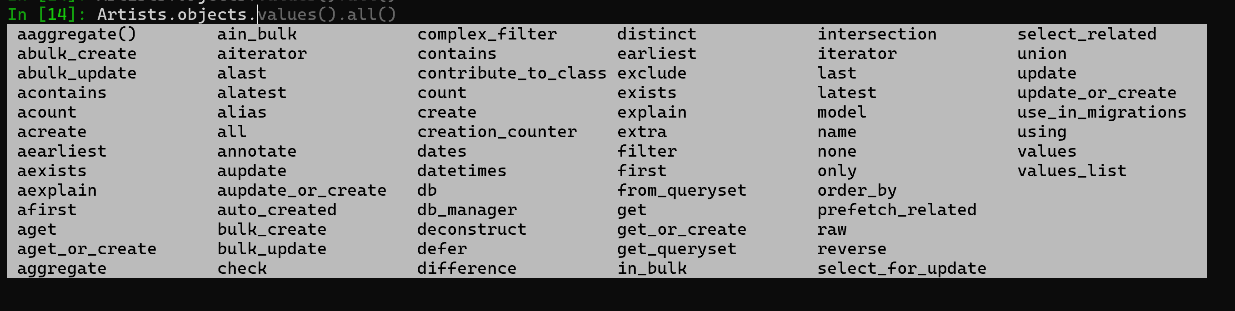

relations

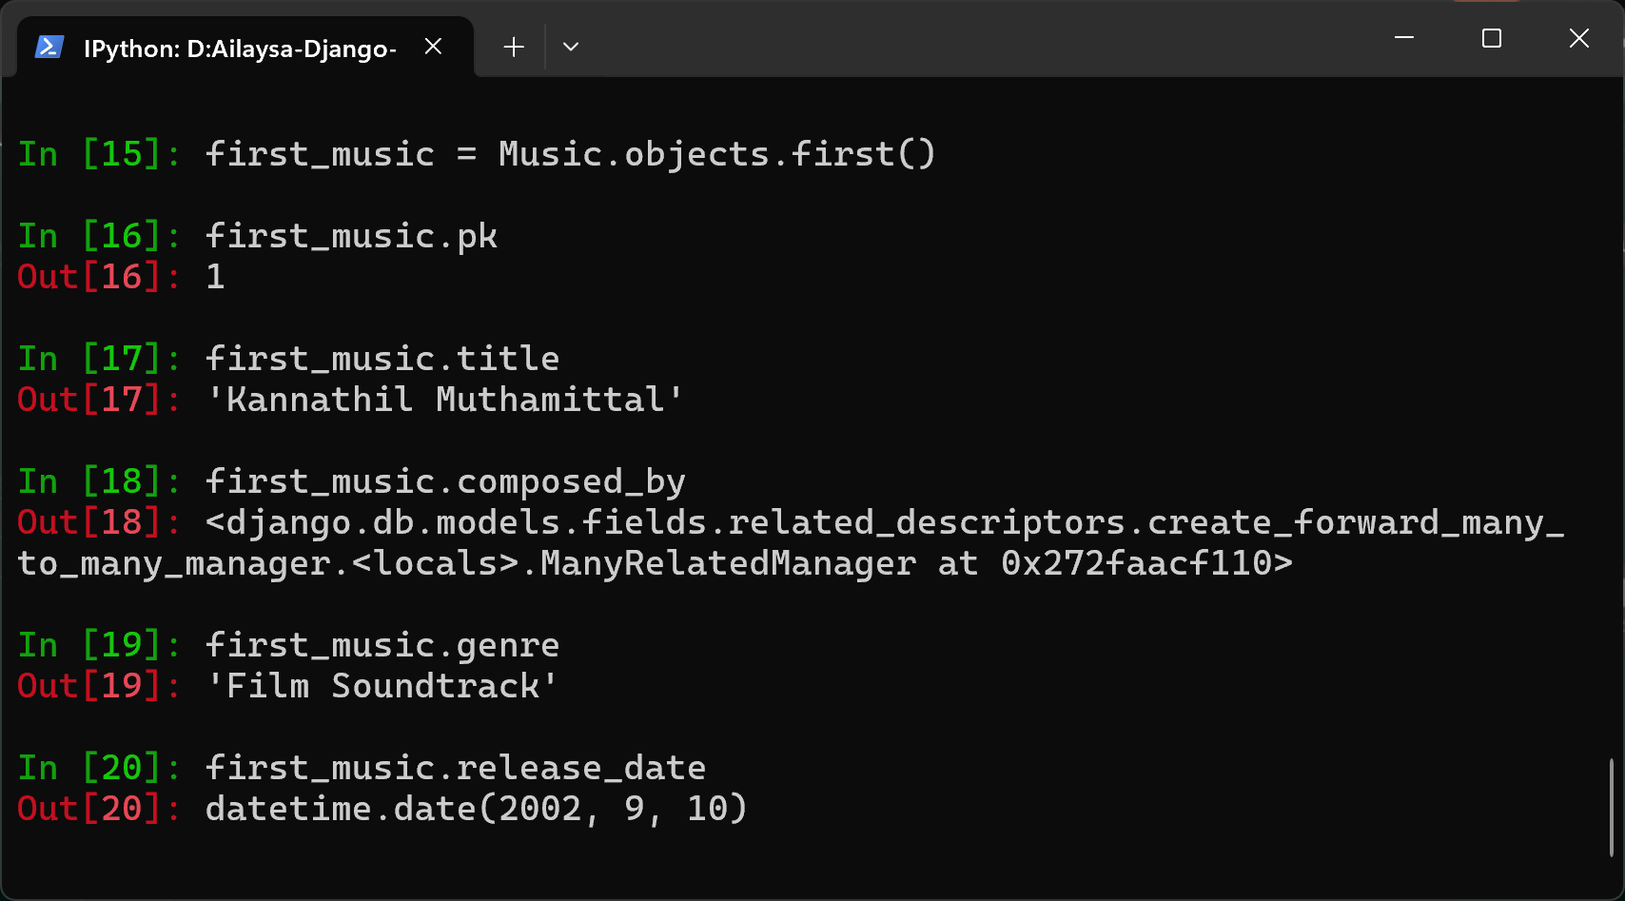

To see ManyToMany relations

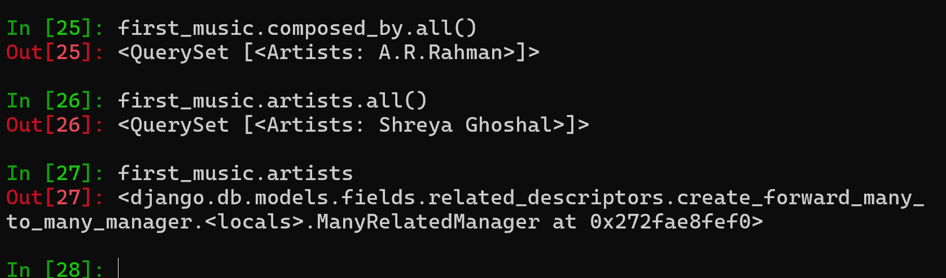

For getting relations, in forward relations we can directly call using their name, but for reverse relations, foreign key and ManyToMany should be called using their related_name

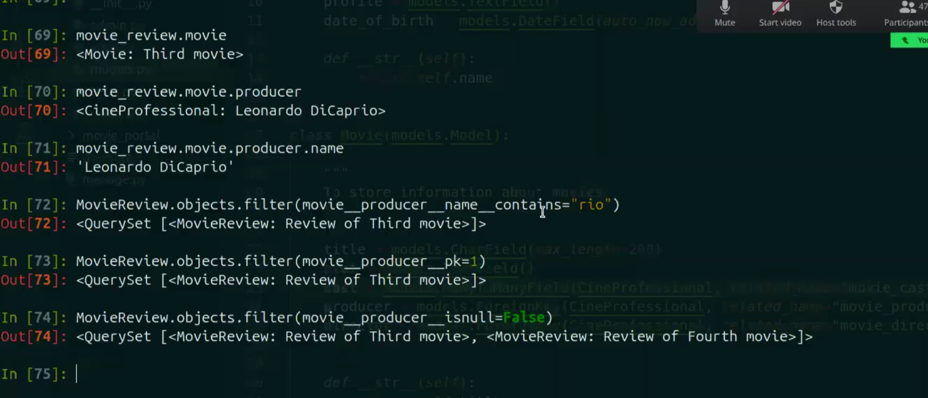

To perform create, delete operations

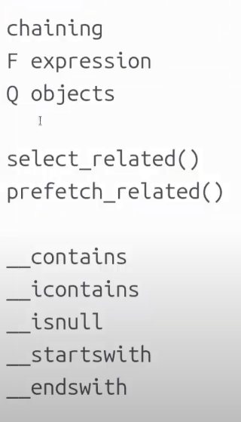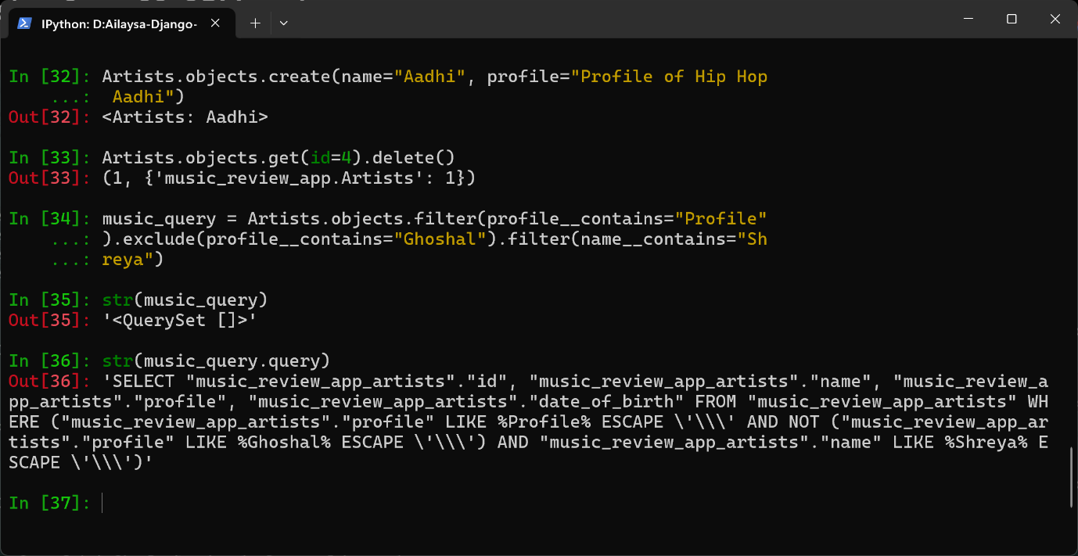

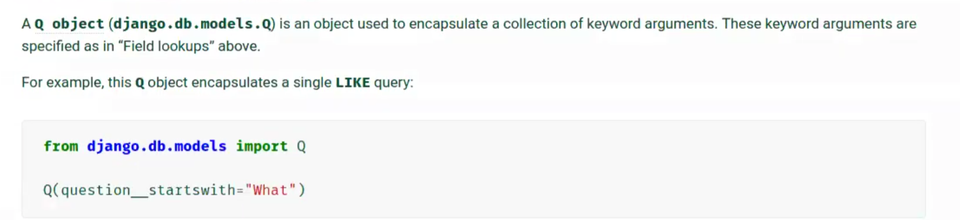

select_related and prefetch_related()





DAY – 3

SERIALIZATION

